

**K. J. Somaiya College of Engineering, Mumbai-77**

**(Somaiya Vidyavihar University)**



**Batch: A-3** **Roll No.: 16010122104**



**Experiment No. 2**



**Grade: AA / AB / BB / BC / CC / CD /DD**



**Signature of the Staff In-charge with date**



**Title:** Represent discrete time signals and perform different operations on them.

**Objective:** To familiarize the beginner to MATLAB by introducing the basic featuresand commands of the program.

**Expected Outcome of Experiment:**

|  |  |
| --- | --- |
| **CO** | **Outcome** |
|  |  |
| **CO1** | Identify various discrete time signals and systems and perform signal |
| manipulation |
|  |
|  |  |

**Books/ Journals/ Websites referred:**

1. http://www.mathworks.com/support/
2. www.math.mtu.edu/~msgocken/intro/intro.html
3. www.mccormick.northwestern.edu/docs/efirst/matlab.pdf
4. A.Nagoor Kani “Digital Signal Processing”, 2nd Edition, TMH Education.

**Pre Lab/ Prior Concepts:**

Using MATLAB we can easily generate all basic functions such as unit step, ramp, growing and decaying exponential, etc. The various signals plotted in this program are Step signal,





**K. J. Somaiya College of Engineering, Mumbai-77**

**(Somaiya Vidyavihar University)**

Ramp signal, Exponential signal etc

**1. Unit Step Signal**

The step signal is defined as

U[n] = k ; if n>=0

= 0 ; otherwise

When k=1 it is called as unit step signal.

**2. Ramp Signal**

The ramp signal is defined as r[n] = n ; if n>=0

* + 0 ; otherwise

1. **Exponential Signal**

The exponential signal is defined as

X[n] =a^n

When ‘a’ is greater than 1 it is **increasing** exponential

When ‘a’ is less than 1 it is **decaying** exponential.

**4. Impulse Signal**

The impulse signal is defined as d[n] = k ; if n=0

= 0 ; otherwise

When k=1 it is called as unit impulse



Dept. of Computer Engg. DSIP Lab Sem VI Jan-Apr 2025 Page 2





**K. J. Somaiya College of Engineering, Mumbai-77**

**(Somaiya Vidyavihar University)**

The functions used in this program are:

1. **Ones**

This function is used to create an array of all ones Syntax: Y=ones (m, n)

**Description:**

Y=ones (n) returns an n-by-n matrix of 1’s.

An error message appears if n is not a scalar.

Y=ones (m, n) or Y=ones([m n]) returns an m-by-n matrix of ones.

**b. Zeros**

This function is used to create an array of all zeros

Syntax: Y=zeros(m,n)

**Description:**

Y=zeros(n) returns an n-by-n matrix of 0’s.

An error message appears if n is not a scalar.

Y=zeros (m,n) or Y=ones([m n]) returns an m-by-n matrix of Zeros.

**c. EXP**

This function is used to plot exponential signals

Syntax: Y=exp(X)

**Description:**

The exp function is an elementary function that operates element-wise on arrays. Its domain includes complex numbers.

Y=exp(X) returns the exponential for each element of X. For complex, it returns the complex exponential.







**K. J. Somaiya College of Engineering, Mumbai-77**

**(Somaiya Vidyavihar University)**

**Steps with Syntax for representation of above discrete time signals:**

% Define the discrete time vector

n = 0:20; % Discrete time from 0 to 20

% Create a new figure

figure;

% Unit Step Signal

subplot(3, 2, 1);

u = (n >= 0);

stem(n, u);

title('Unit Step Signal');

xlabel('n');

ylabel('u[n]');

grid on;

% Unit Impulse Signal

subplot(3, 2, 2);

delta = [1, zeros(1, 20)];

stem(n, delta);

title('Unit Impulse Signal');

xlabel('n');

ylabel('δ[n]');

grid on;

% Ramp Signal

subplot(3, 2, 3);

ramp = n;

stem(n, ramp);

title('Ramp Signal');

xlabel('n');

ylabel('r[n]');

grid on;

% Exponential Signal

subplot(3, 2, 4);

a = 0.9;

x_exp = a.^n;

stem(n, x_exp);

title('Exponential Signal');

xlabel('n');

ylabel('x[n]');

grid on;

% Sine Signal

subplot(3, 2, 5);

f_sin = 0.1;

x_sin = sin(2 * pi * f_sin * n);

stem(n, x_sin);

title('Discrete-Time Sine Signal');

xlabel('n');

ylabel('x[n]');

grid on;

% Cosine Signal

subplot(3, 2, 6);

f_cos = 0.1;

x_cos = cos(2 * pi * f_cos * n);

stem(n, x_cos);

title('Discrete-Time Cosine Signal');

xlabel('n');

ylabel('x[n]');

grid on;

**Output:**

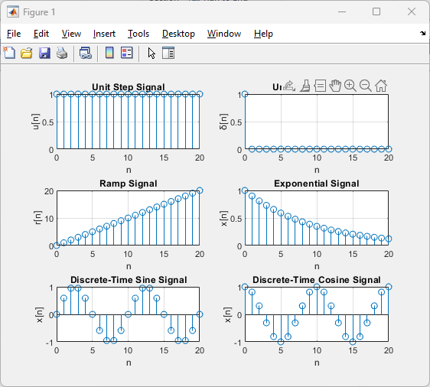



**K. J. Somaiya College of Engineering, Mumbai-77**

**(Somaiya Vidyavihar University)**

**Operations on Signals:**

1. Addition of signals.
2. Subtraction of signals.
3. Multiplication of two signals.
4. Scaling – Upscaling & Downscaling.
5. Shift operation – Advance/Right shift & Delay/Left shift.



**K. J. Somaiya College of Engineering, Mumbai-77**

**(Somaiya Vidyavihar University)**

**Steps with Syntax for representation of above operations on discrete time signals:**



t = -10:0.5:10;

signal1 = sin(t);

signal2 = 0.5 * cos(t);

addition_result = signal1 + signal2;

subtraction_result = signal1 - signal2;

multiplication_result = signal1 .* signal2;

upscaling_factor = 2;

downscaling_factor = 0.5;

upscaled_signal = upscaling_factor * signal1;

downscaled_signal = downscaling_factor * signal1;

shift_amount = 2;

advanced_signal = circshift(signal1, shift_amount);

delayed_signal = circshift(signal1, -shift_amount);

folded_signal = fliplr(signal1);

subplot(3, 3, 1);

plot(t, signal1);

title('Signal 1');

subplot(3, 3, 2);

plot(t, signal2);

title('Signal 2');

subplot(3, 3, 3);

plot(t, addition_result);

title('Addition');

subplot(3, 3, 4);

plot(t, subtraction_result);

title('Subtraction');

subplot(3, 3, 5);

plot(t, multiplication_result);

title('Multiplication');

subplot(3, 3, 6);

plot(t, upscaled_signal);

title('Upscaling');

subplot(3, 3, 7);

plot(t, downscaled_signal);

title('Downscaling');

subplot(3, 3, 8);

plot(t, advanced_signal);

title('Advance/Right Shift');

subplot(3, 3, 9);

plot(t, delayed_signal);

title('Delay/Left Shift');

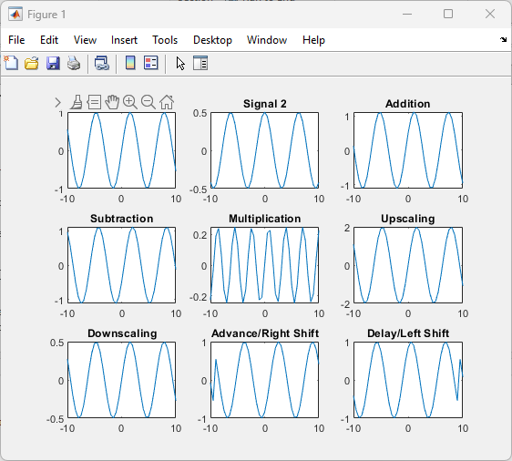



**K. J. Somaiya College of Engineering, Mumbai-77**

**(Somaiya Vidyavihar University)**

**Conclusion:-**

We learnt represent discrete time signals and perform different operations on them.

|  |  |
| --- | --- |
| **Date: 21/01/2024** | **Signature of faculty in-charge** |

**Post Lab Questions**

1. **Let x(n) = 8(0.5)n (u[n+1] - u[n-3]). Sketch the following signals**
2. **Y(n) = [x-3]**
3. **F(n) = x[n+1]**
4. **G(n) = x[-n+4]**

n = -10:10;

u = @(n) double(n >= 0);

x = @(n) 8*(0.5).^n .* (u(n+1) - u(n-3));

x_n = x(n);

Y_n = x(n - 3);

F_n = x(n + 1);

G_n = x(-n + 4);

figure;

subplot(4, 1, 1);

stem(n, x_n, 'filled');

title('Original Signal x(n)');

xlabel('n');

ylabel('Amplitude');

subplot(4, 1, 2);

stem(n, Y_n, 'filled');

title('Y(n) = x[n-3] (Right Shift by 3)');

xlabel('n');

ylabel('Amplitude');

subplot(4, 1, 3);

stem(n, F_n, 'filled');

title('F(n) = x[n+1] (Left Shift by 1)');

xlabel('n');

ylabel('Amplitude');

subplot(4, 1, 4);

stem(n, G_n, 'filled');

title('G(n) = x[-n+4] (Time Reversal and Right Shift by 4)');

xlabel('n');

ylabel('Amplitude');

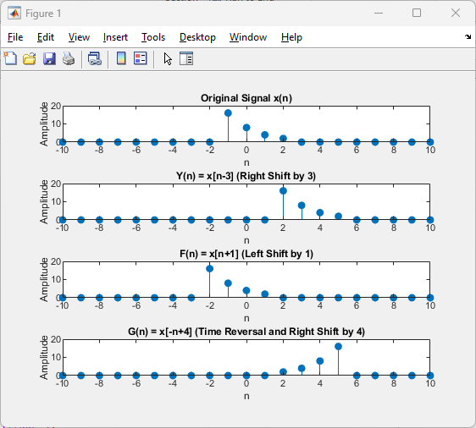

1. **The process of conversion of continuous time signal into discrete time signal is known as** Sampling .
2. **Which of the following is example of deterministic signal?**
   1. Step
   2. Ramp
   3. Exponential
   4. **All of the above**
3. **For energy signals the energy will be finite and the average power will be** Zero .
4. **In a signal x(n), if ‘n’ is replaced by ‘n/3’ the it is called** time scaling **.**
5. **The system y(n)=sin[x(n)] is**
   1. Stable
   2. **BIBO stable**
   3. Unstable
   4. None of the above